Exp.No-11
11. Perform Affine Transformation on the image.

Aim:
To perform affine transformation on an image using OpenCV.
Procedure:
- Start the program.
- Import the OpenCV and NumPy libraries.
- Read the input image.
- Select three source points.
- Select three destination points.
- Compute the affine transformation matrix.
- Apply the affine transformation.
- Display the original and transformed images.
- Save the transformed image.
- Stop the program.
Program:
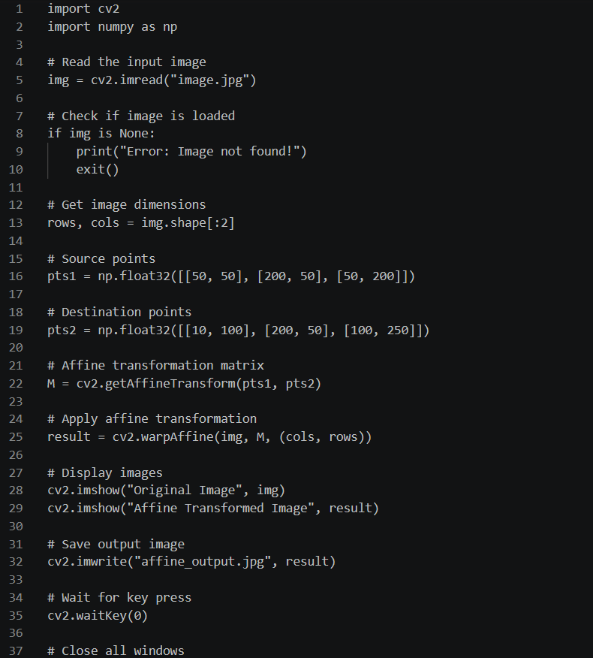
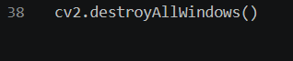
Input:



Output:

Result:
The perspective transformation was successfully performed on the input image using OpenCV. The transformed image was displayed and saved successfully.

